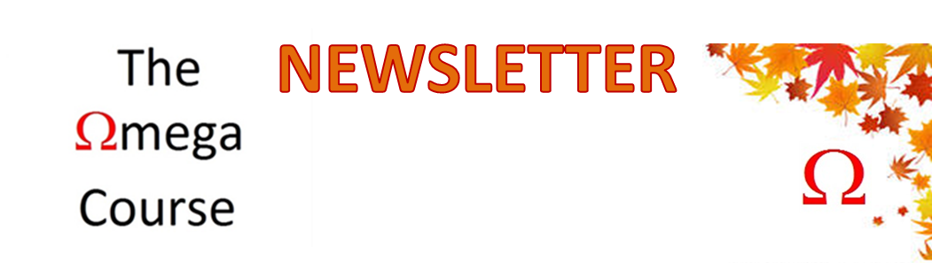
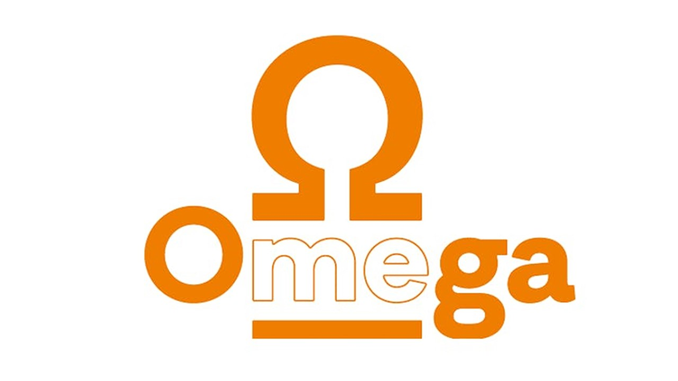
August 2021

The world around us is awakening after lockdown. It is our emotional spring and yet the mornings have a whiff of Autumn. Where has 2 years gone since our last newsletter? There does seem to be a lot to tell you.
Colin Briffa and I ran courses in July and November 2019 here in Kenilworth. Quite a commitment for Colin as he had moved away to Leyland by then. We talked a lot about the content of the course and how we needed to train facilitators to help run courses independently. However, some elements of the course, particularly the communication skills day, are challenging to deliver. Colin was busy drafting the facilitator handbook and we were finalising the website and planning courses for 2020 when along came The Coronavirus Pandemic. Every time we planned a course and venue the rules changed.
In the end we thought it would have to be online which caused a frisson of apprehension and a lot of training for online delivery.
In December 2020 Colin decided to take a sabbatical from Omega till 2022 as he felt his new life in Leyland was offering many opportunities. I am grateful and proud of all Colin has contributed to The Omega Course. Indeed, it was he that gave the impetus for its conception by saying “Chantal you have been talking about this for ages. I am going to help you do something about it.” The Omega Course was born. I am an ideas person, Colin is eminently practical and delivers.
Perhaps his sabbatical was prescient as, very sadly, his wife Pat died suddenly in February 2021. A horrible shock to us all. We see Colin from time to time and continue to wish him well and be thankful for him and Pat who put so much time and work into Omega Soirees.

Omega Online
Kenilworth Lions were very generous in funding a bid to develop our capability online with better equipment. It also gave me a bit more impetus as the grant was dependent upon us getting the online course started before the end of the financial year. I was still nervous launching Omega Online in April 2021 but the training I had done was helpful and my nerves subsided as people engaged.
Omega online is the same…. but different. Evaluations were great and even over the airwaves some very special moments happened. I was pleased to hear people’s surprise at how much they laughed. That is the same comment as we get from in-person courses and represents the relationships formed. We now have a flexible hybrid offering to suit people’s preference.
I could not have delivered the course online without some wonderful breakout room facilitators and the excellent technical support given so generously by Bob Dudley. All I had to bring were the nerves! Thank you all.
It would be lovely to have offers of future facilitators for online courses.
There is no reason, that The Omega Course could not run from an online platform independently rather than live over Zoom. It would again be different but the same basic content. I understand the concept but am limited in knowhow and funding to take the step. I believe we should.

Grants
Getting grant funding is a priority but time consuming. Local charities are extremely supportive but for National grants it is way more competitive. The Fore grantfunders gave us some very constructive feedback. The praised our ‘most compelling argument’ and a good project. 1 in 10 projects get funded and although we did not this time round we got as far as an interview which very few do. They hoped we would apply again.
We are charging for our courses this year as we have no funding to subsidise them and future developments.
Do you have grant writing and administrating skills? If so we need you.
One exciting development has been signing up The Omega Course to the easyfundraising platform. If you shop online you can assist us by adding yourself to their system, it is easy.
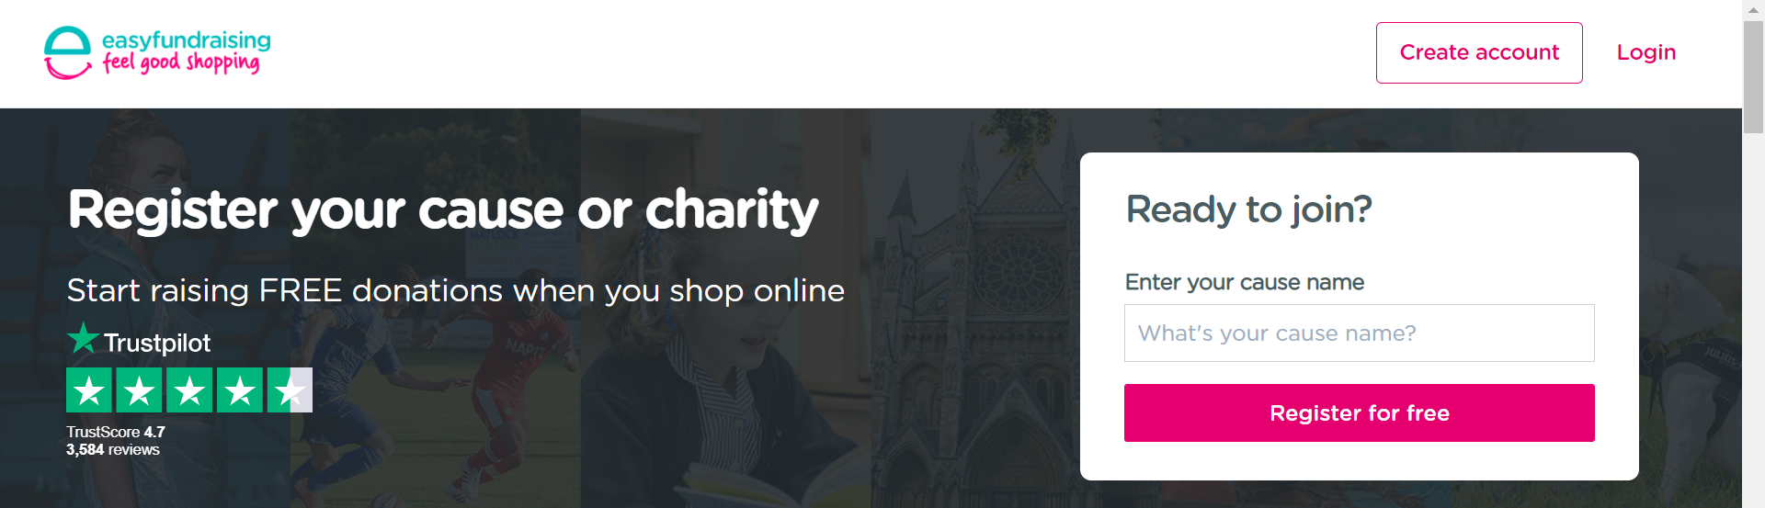
Click on the pink register for free button and on the next screen type in The Omega course. Each time you shop online from participating companies we earn some pennies. I got car insurance through Go Compare and they gave the charity £16:50! Usually get 20-40p.

Omega^{Pro}
Omega^{Pro} is a one day course for clinical professionals. We ran it twice just before the pandemic arrived. Its aim is to help clinicians address their own mortality as not doing so has been shown to limit their ability to talk to patients about dying. The content of the Omega course is ideal for this. In February 2021 I was invited to present our results to the National Institute of Health Research West Midlands Supportive and Palliative Care Research Showcase. The slides below demonstrate our efficacy. (It is good if all the blue results move to the right as orange results.)
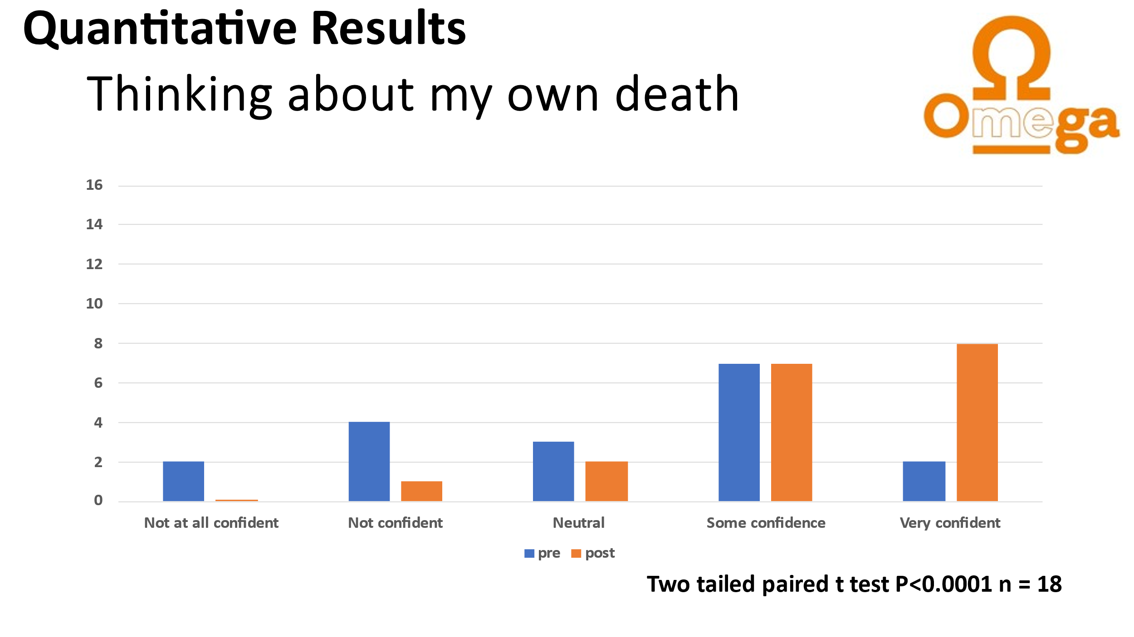
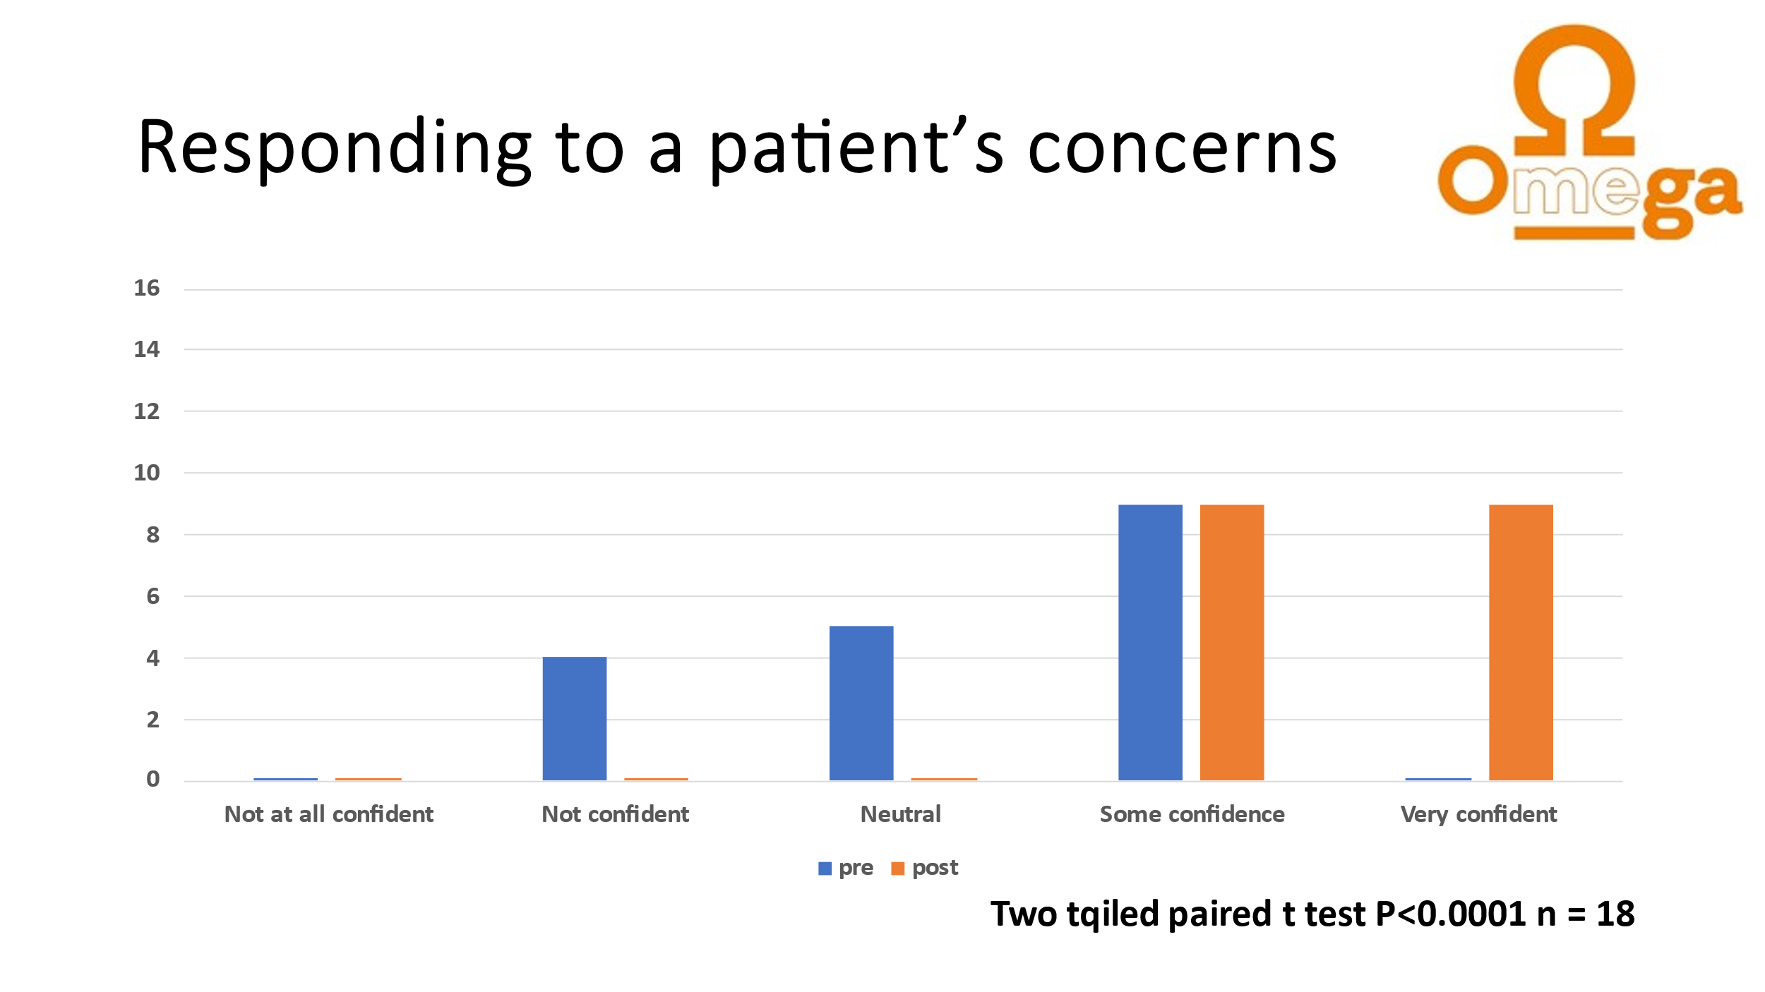
Contemplating mortality was challenging, but educational and helped develop insight. Putting the ’Me’ back into delivering patient care for these senior clinicians was useful for communication skills training that we did in the afternoon.
All 14 rated the course highly and recommended colleagues should do the course. Grateful thanks to Hilary Scott for helping make the day interesting and run smoothly. So helpful to have another facilitator. Fancy a go?

Partnership with UHCW + Death Cafés
We have been working with the University Hospital Coventry and Warwickshire Communities Team to plan and deliver Death Cafés across the County. Despite some people being put off by the name Death Cafés are the gentlest way to approach the topic of death. The agenda is simply to chat to people who come about their questions or comments. We don’t have to know the answers even, it is just good to talk. Like most other activities Covid 19 has affected delivery as folk usually share cake but they have to be shop made, individually wrapped at present. The chat was just as good.
Watch out for the following venues:
- Shipston 25th September
- Kenilworth and Leamington 2nd October
- Leamington 13th November
- Stratford 4th December

Lions Fair September 11th 2021
After a couple of years of disappointment and cancellation we are looking forward to the 2021 Lions fair. We have a site at the new Talisman Square venue and they are providing a market stall.
We will not have electricity but I have A4 stand up frames, 2 quizzes, leaflets and goody bags. Set up is from 08:30hrs with the public visiting between 10:00 and 15:00hrs. Volunteers to chat to folk for part of the time would be wonderful.

Weekend Omega Course
Many working people cannot commit to a four week run of weeknights to attend The Omega Course so I have planned a weekend course 16th/17th October at the Senior Citizens Club in Kenilworth. The hours are 10:00-16:00 Saturday and 11:30-16:30 Sunday. The cost of this course is £65 or £100 for two places booked at the same time.

Evening Omega Course
The evening course will run in the standard format of 4 weeknight evenings and the penultimate Saturday at the Senior Citizens Club Kenilworth. The Saturday will give the opportunity of the full day of communication skills training, making this course a bargain at the same price as the weekend course at £65 per person or £100 for 2 people booked together. Concessions are available.

Dates:
28th October 19:30 – 21:30
04th November 19:30 – 21:30
11th November 19:30 – 21:30
13th November 10:00 – 16:00
18th November 19:30 – 21:30

Communication Skills Day
Some may wish to extend their skills with a separate communication Skills training Day. Details to follow

Recurring Theme
You may have noticed a recurring theme through this newsletter. Do you have skills and a bit of time to spare? We need volunteer facilitators to help with content, make coffee and give out printed materials. Technical assistance and admin is also very welcome. If you have time to encourage and support do ring Chantal on 07743376708.

